SNC2P February 2017

Name: _____________________________________________

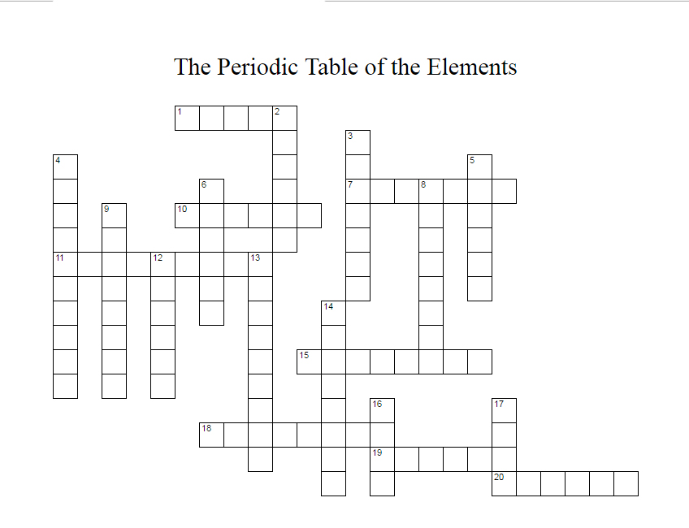
ACROSS |  | DOWN
1. | Ar | 2. | Ni
7. | Li | 3. | Ca
10. | Cu | 4. | P
11. | K | 5. | S
15. | Al | 6. | Na
18. | F | 8. | H
19. | O | 9. | N
20. | C | 12. | Ag
 |  | 13. | Mg
 |  | 14. | Cl
 |  | 16. | Ne
 |  | 17. | Zn

