SCH3U Sept. 2016

Periodic Trends

Draw the Bohr-Rutherford diagram for:
Potassium | Bromine | Uranium

Effective Nuclear Charge (enc):
- is the charge that valence electrons ___________ ______________ from the nucleus

- Determine the enc acting on the valence electrons of
Potassium: Bromine: Uranium:

Factors that affect the effect of the nucleus on the valence electrons:

- Effective nuclear charge: the bigger the enc, the _________ valence electrons are pulled toward the nucleus and the ______________ they are held in the atom

- Valence level: the higher the valence level, the ___________ valence electrons are from the nucleus and the ________________ they are pulled in/held in the atom

Impact on 4 properties of elements
- Atomic Radius (size of the atom)
- Ionization energy
- Electron affinity
- Chemical reactivity

- Atomic Radius: is the size of the atom, assuming the atom is a sphere

- Study the following chart of atomic radii.

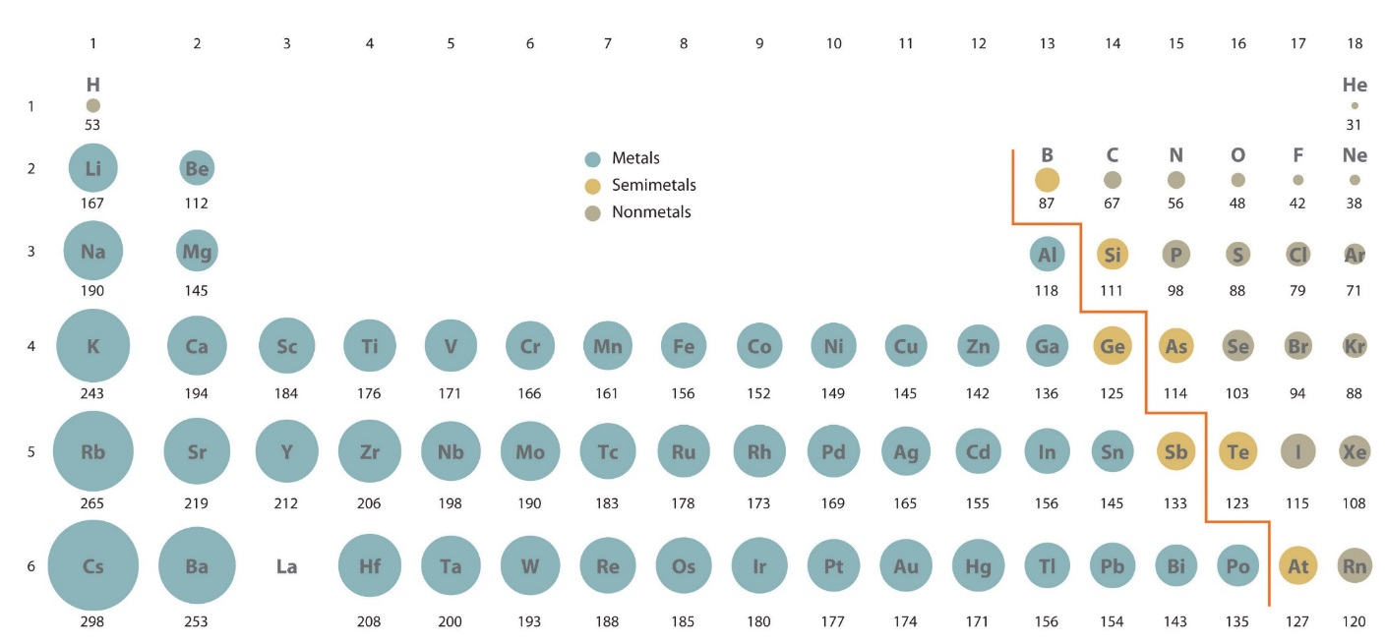

- What happens to the radius as you go down a family?

- What is changing in the atoms as you go down a family: the enc or the valence level?

- In light of your answer above, try to explain this observed trend.

- What happens to the radius as you go left to right across a period?

- What is changing in the atoms as you go across a period: the enc or the valence level?

- In light of your answer above, try to explain this observed trend.

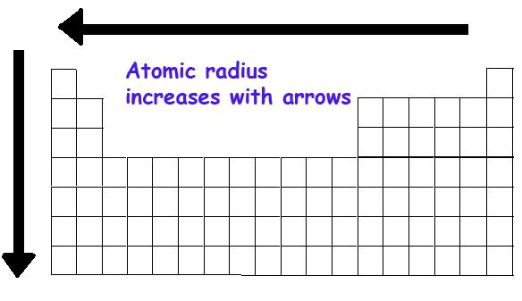
- Complete #2,3,4 on page12 in your work book.

- Ionization Energy: is the energy that is needed to ____________ a valence electron from an atom. The greater the ionization energy, the __________ ________________ it will be for the atom to lose an electron

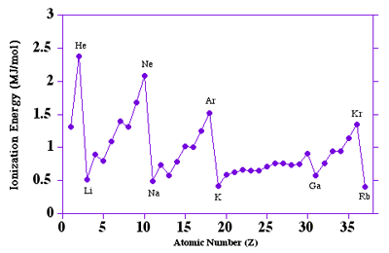

- What happens to the IE as you go down a family?

- Does this mean that it is easier or more difficult for an atom to lose an electron

- How is the atom changing in size as you go down a family?

- What happens to the IE as you go across a period?

- How is the atom changing in size as you go across a period?

- How is the size of the atom related to its IE?

- How is the size of the atom related to the ease with which it can lose its valence electrons?

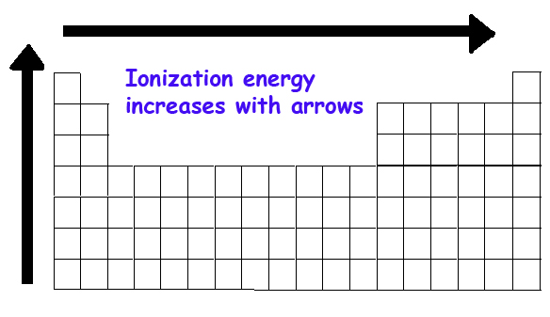

- Complete #3 on page14 in your work book.

- Electron Affinity (EA): is the attraction an atom has for ______ ____________. The higher the affinity, the more likely the atom will ____________an electron

- Based on the trends for atomic radius and IE, you should be able to predict the trend in EA.

- As you go down a family the EA ______ and as you go across a period the EA ________.

- How is the size of the atom related to EA?

- Complete #4 on page 14 in the work book.

