SCH4U December 2016
A New Way of Thinking About the Atom and Bonding
The Quantum Mechanical Model of the Atom
In grade 11, you learned that the electrons in an atom position themselves around the nucleus in sublevels within energy levels. This was illustrated by writing out electron configurations. For example, the electron configuration for nitrogen is 1s² 2s² 2p³. This was a good beginning to the quantum mechanical model. However, the idea that electrons travel in circular paths around the nucleus, as Bohr’s model suggested, is no longer accepted. Instead, electrons occupy regions of space or electron clouds called orbitals, where the probability of finding an electron is high. There is no set path for the electrons to follow and the electrons can be found anywhere within the orbital. There are some restrictions to these orbitals:
- a maximum of 2 electrons can be found within an orbital
- an electron will choose not to share an orbital with another electron until all of the orbitals in that sublevel are half-filled
- electrons within the orbitals spin either clock-wise or counter clock-wise
- when 2 electrons are in the same orbital, they spin in opposite directions
- when orbitals within a sublevel each possess one electron, the electrons all spin in the same direction
- since only 2 electrons can occupy an orbital, the “s” sublevel has only 1 orbital or region of high probability, “p” has 3, “d” has 5 and “f” has 7
A good way to illustrate the above ideas is to draw orbital diagrams. For example, the orbital diagram for nitrogen is:
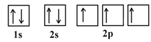
- In class you will learn how to draw the orbital diagram for any atom or ion as well as a few anomalies.
Each type of orbital has a distinctive shape:
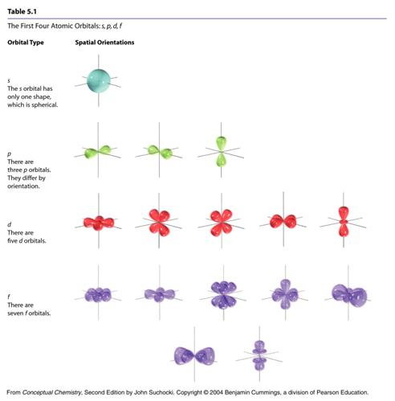
Valence Bond Theory
In grade 11, you learned how to illustrate the sharing of valence electrons between two non-metals in a covalent bond by drawing either Lewis diagrams or structural diagrams. We now need to incorporate the orbital idea into bonding.
The valence bond theory states that a covalent bond is formed when two half-filled orbitals (one from each atom) overlap (share the same space) to produce a new combined orbital containing two electrons of opposite spin. This arrangement decreases the energy of the atoms in the bond making them more stable.
- In class, you will practice drawing a variety of molecules using the valence bond theory.
Hybrid Orbitals
We hit a bump in the road when we attempt to draw the bonding orbitals for CH₄. This is because carbon needs to form a hybrid orbital in order to bond with four hydrogens. A hybrid orbital is an atomic orbital obtained by combining the properties of two different orbitals i.e. s and p. A hybrid forms when the number of bonds the central atom needs to make exceeds the number of half-filled orbitals for that atom (as seen with carbon in CH₄).
- In class, you will learn to identify and draw a variety of hybrid orbitals.

