SCH4U Review for Equilibrium: Sample Questions April 2017

- Consider the reaction: PCl_{3(g)} + Cl_{2(g)} PCl_{5(g)} + heat
- When 1.00 mol of PCl₃ and 2.00 mol of Cl₂ are placed in a 10.0 L container and allowed to reach equilibrium, the [PCl₃] = 0.080 M. Determine the value of K_{eq} by first creating the ICE chart.
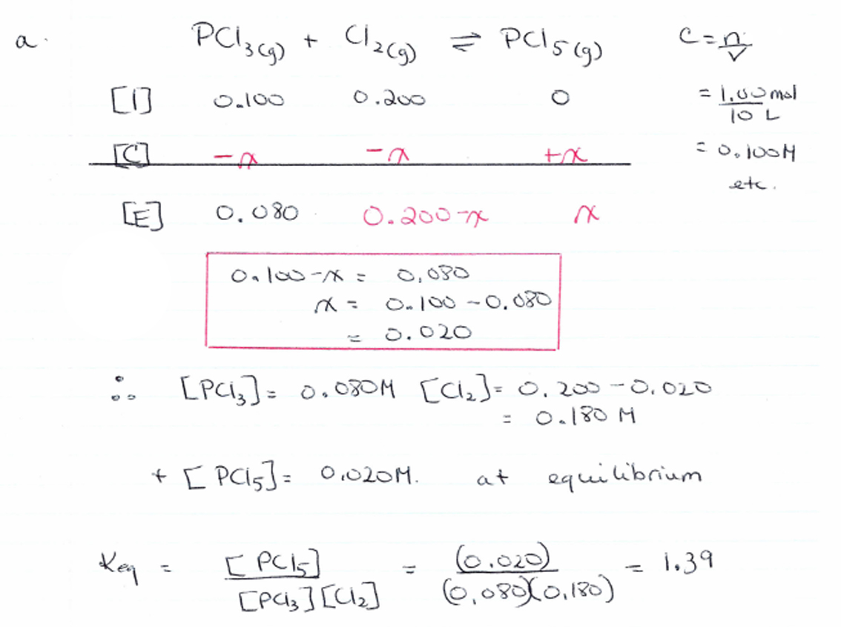

- What is the percent yield for the reaction?
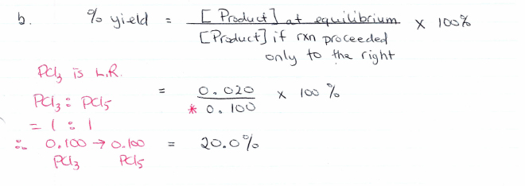

- What 3 things could be done to increase the % yield given that the forward reaction is exothermic?

c) To increase the percent yield, the reaction needs to proceed further to the right. i.e. make more product
1) increase pressure of the mixture by placing it in a smaller container. This will cause the reaction to shift to the side with the least number of moles of gas
2) decrease the temperature of the equilibrium mixture. This will cause the reaction to proceed in the direction that produces heat.
3) remove some of the PCl₅ from the mixture. This will cause the reaction to proceed to the right to make more product.
4) add more Cl₂ to the mixture

- Make a sketch of the concentration-time graph using the data from part a). Sketch how the graph would change as you apply each of the stresses in part c).
We will take this up in class together.

- What is the K_{eq} for the reverse reaction: PCl_{5(g)} PCl_{3(g)} + Cl_{2(g)}
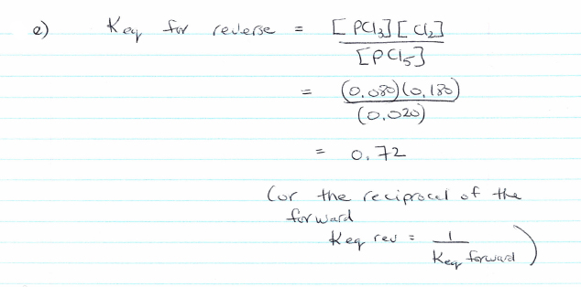

- Consider the reaction: A_{(aq)} + B_{(aq)} C_{(aq)} + D_{(aq)} K_{eq} = 2.
If the initial concentrations of A, B, C and D are 0.10 M, 0.10M, 0.30M and 0.40M respectively, what will the final concentration of A be?

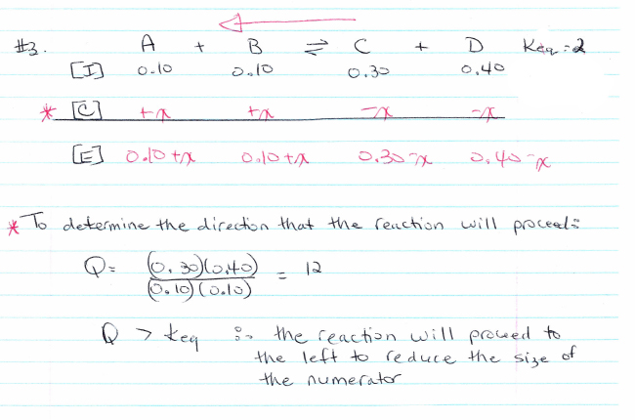

2 = (0.30 – x)(0.40 – x)
(0.10 + X)(0.10 + x)

2(0.010 + 0.20x + x²) = 0.12 – 0.70x + x²

0.020 + 0.40x + 2x² = 0.12 – 0.70x + x²

2x² – x² + 0.40x + 0.70x + 0.020 – 0.120 = 0

X² + 1.1x – 0.10 = 0

X = 0.084 or -1.18

Therefore [A] = 0.10 + 0.084 = 0.18 M

- Consider the reaction: A_{(g)} + B_{(g)} 2C_{(g)} K_{eq} = 5
What will the equilibrium concentration of C be when 1.0 moles of C is initially added to a 1L container?
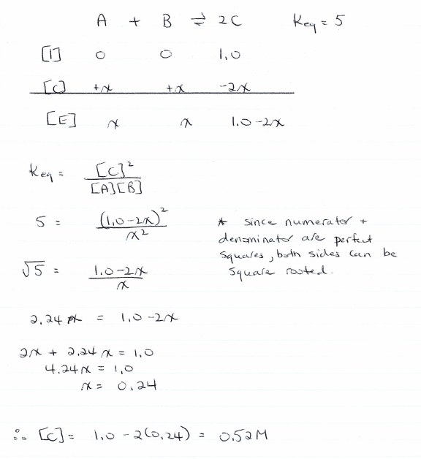

- Consider the following equilibrium: NH_{3(aq)} + H₂O_{(l)} NH₄⁺_{(aq)} + OH⁻_{(aq)}

At equilibrium, the concentrations of NH_{3(aq)}, NH₄⁺_{(aq)} and OH⁻_{(aq)} are 1.00M, 0.0010M and 0.018M respectively. To 500 .0 mL of this equilibrium mixture, 0.050 mol of OH⁻ are added. Calculate the new equilibrium concentrations of NH₄⁺ and OH⁻.
NH_{3(aq)} + H₂O_{(l)} NH₄⁺_{(aq)} + OH⁻_{(aq)}

[I] 1.00 0.0010 0.018
Stress +0.10
[C] +x -x -x
[E] 1.00+x 0.0010-x 0.118-x

K_{eq} = [NH₄⁺][ OH⁻] = (0.0010)(0.018) = 1.8x10⁻⁵
[NH₃] 1.00 + x

1.8x10⁻⁵ = (0.0010-x)( 0.118-x)
1.00 +x
1.8 x 10⁻⁵ (1.00 + x) = 1.18x10⁻⁴ – 0.119x + x²
1.8 x 10⁻⁵ + 1.8 x 10⁻⁵x = x² – 0.119x + 1.18x10⁻⁴
x² - 0.119x - 1.8 x 10⁻⁵x + 1.18 x 10⁻⁴ - 1.8 x 10⁻⁵ = 0
x² - 0.119x + 1.0 x 10⁻⁴ = 0

x= 0.119 ± √(0.119² –4(1)(1.0x10⁻⁴)
2
x = 8.46x10⁻⁴
Therefore [NH₄⁺] = 0.0010 – 0.000846 = 1.54x10⁻⁴M
[OH⁻] = 0.118 – 0.000846 = 0.117M

