SCH4U September 2017
Measuring Energy Changes in a Chemical Reaction: Calorimetry
EVERY chemical reaction either releases energy __________________________________ (exothermic reactions)
OR absorbs energy ________________________________________________________ (endothermic reactions)

We __________________________the energy changes in the chemical reaction (the system)

BUT we can ________________________________ the energy changes in the surroundings

If we assume that:
heat lost/gained by the system = ______________________________________________
then we can experimentally determine the energy changes in chemical reactions

To measure the heat gained/lost by the surroundings we need a device called a ____________

Calorimeters can be as simple as a _____________ or as sophisticated as a ______________

Example 1: What amount of heat is released when 2.56 g of ethane burns? (See diagram)
Assumption:  All heat lost by the reaction goes into the copper calorimeter and the water.  Given:  The temperature of both the copper calorimeter and the water increase by 70.3 ºC The specific heat capacity of water is 4.18 J/gºC  The specific heat capacity of copper is 0.385 J/gºC | 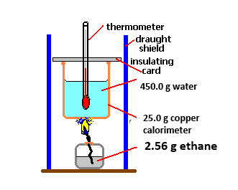
q = mcΔT (can only be used for surroundings)
Heat gained by the water:
q = mcΔT =

Heat gained by the copper calorimeter:
q = mcΔT =

Heat lost by the reaction (q_{rxn}) = q_{water} + q_{copper}

This is called the “heat of the reaction”.

What amount of heat is released when 1 mole of ethane burns? (units will be kJ/mol)
2.56 g of ethane = ________ mol of ethane

Therefore the heat released/mole of ethane is: q_{rxn} /n =

Now that the units are “standardized” we call this energy change “___________________”. Rather than using the symbol “q”, we use the symbol “_____”.

Since heat has been lost by the system, it is an _________ reaction and we indicate this loss by using the (–)ve sign.

Therefore: ΔH =

Example 2: What is the heat of the reaction when 10.0 g of propane burns? (see diagram)
Given:  The temperature of both the calorimeter and water increases from 25.0ºC to 90.5ºC  The heat capacity of the calorimeter is 2.0 kJ/ºC  The specific heat capacity of water is 4.18 J/gºC  q = mcΔT and q = C ΔT |  |  | 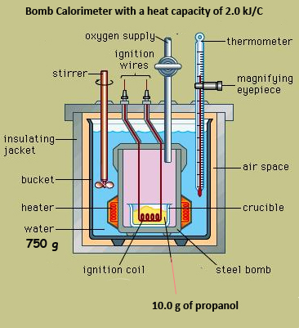
Surroundings: water and Calorimeter  Heat gained  q_{water} =  q_{calorimeter} =  q_{total} = q_{water} + q_{calorimeter} | System: propane and oxygen  Heat released  q_{rxn =}
What is the molar enthalpy of combustion of propane?
Moles of propane burned =

Therefore ΔH =

Example 3: What is the molar enthalpy of dissolution (dissolving) of NaOH? (see diagram)
Given:  Heat absorbed by coffee cup = 0 J  Water temperature increases from 25ºC to 38.3ºC |  | 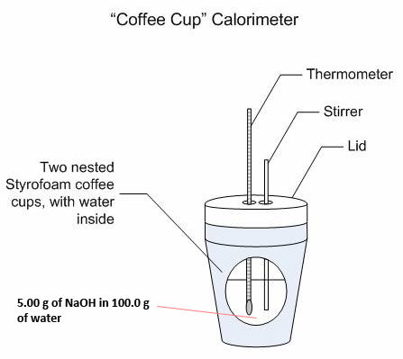

Surroundings: coffee cup and water  Heat absorbed  q_{water} =  q_{styrofoam} =  q_{surroundings} = | System: NaOH and water  Heat released  q_{rxn} =  n_{NaOH} =  ΔH =

